**WORKSHEET. WEEK 28. GRADE 4**

**REVIEW 3. UNIT 7, 8 & 9**

**1/ Write sentences. Put the adverbs in brackets into the correct place.**

1. I play tennis. (never).

I never play tennis .

2. We do our homework in the library. (sometimes)

________________________________________

3. Karl wakes up before 7 o’clock. (usually)

________________________________________

4. Mum and Dad don’t go to the theatre. (often)

________________________________________

5. I’m tired. (always)

________________________________________

**2/Complete the sentences using in, on or at**.

1/ My birthday is in March. 2/ We go to the café ___ Saturdays.

3/ There’s a party ___8 o’clock tonight. 4/ Calum is going to Paris __ Saturday.

5/ The class starts____ 9 o’clock. 6/Mum and Dad go on holiday___August.

**3 Write a, an or some.**

1 some rice. 5 ________orange. 9________ spinach .

2 ______ water. 6 _______ Lemon. 10 _________glass of orange juice.

3 ______ tea. 7_______ dates. 11_________grapes.

4________ sandwich. 8 ______coffee. 12 _________lemonade.

**4/ Read and circle Yes or No:**

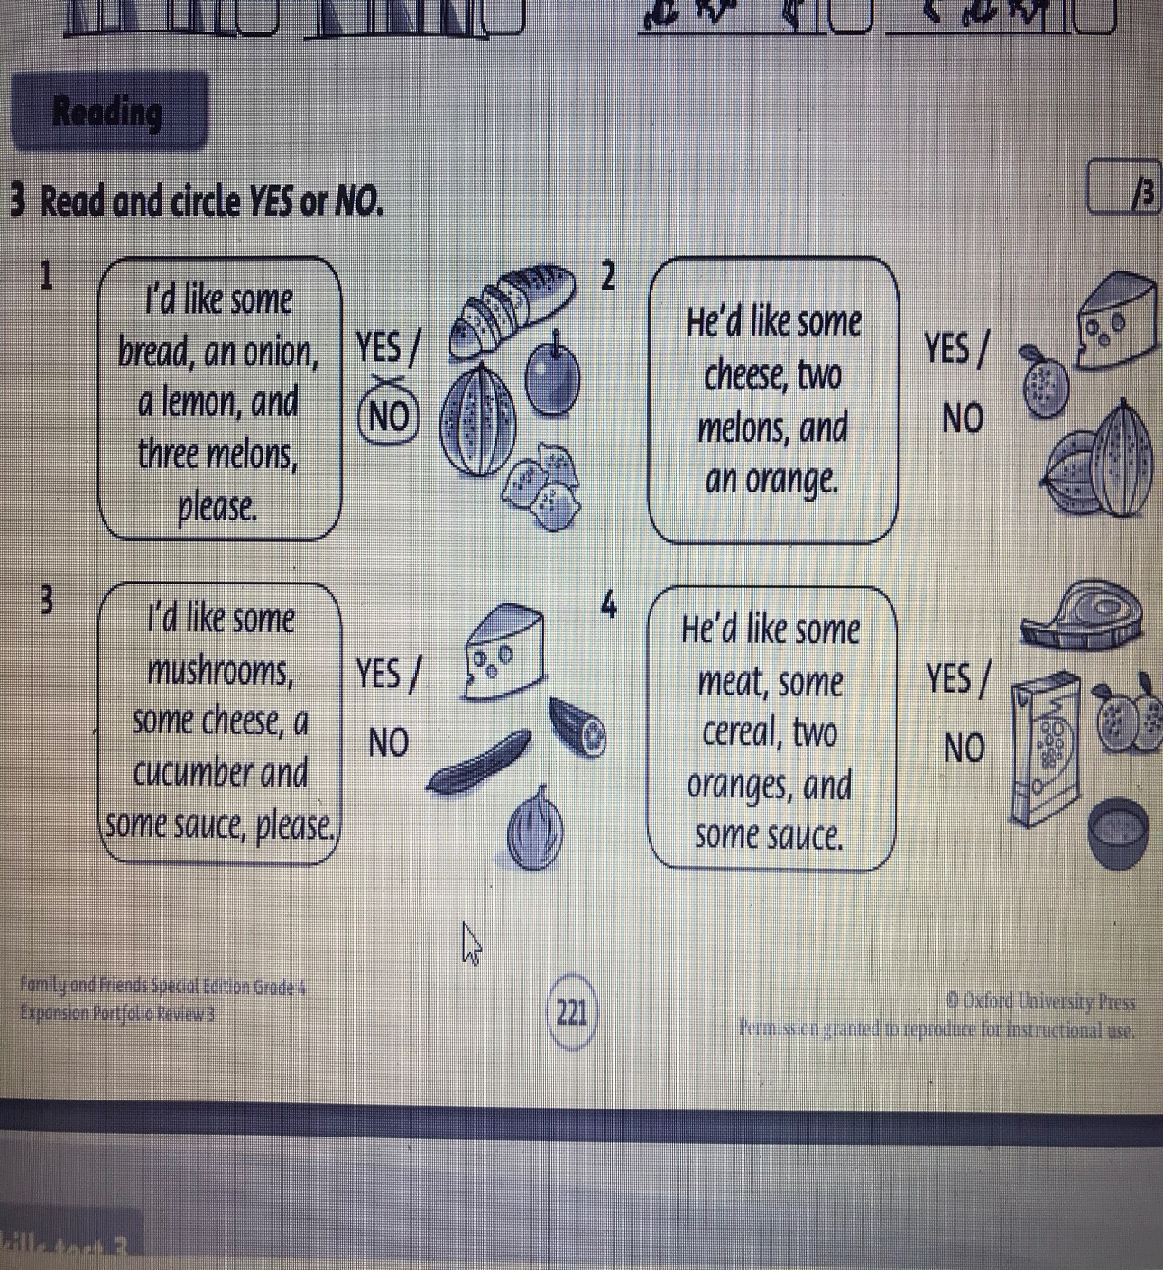

**5**/ **Look at the pictures**. Write two sentences for each picture, using a comparative adjective and a superlative adjective.

**wide big fast long old**

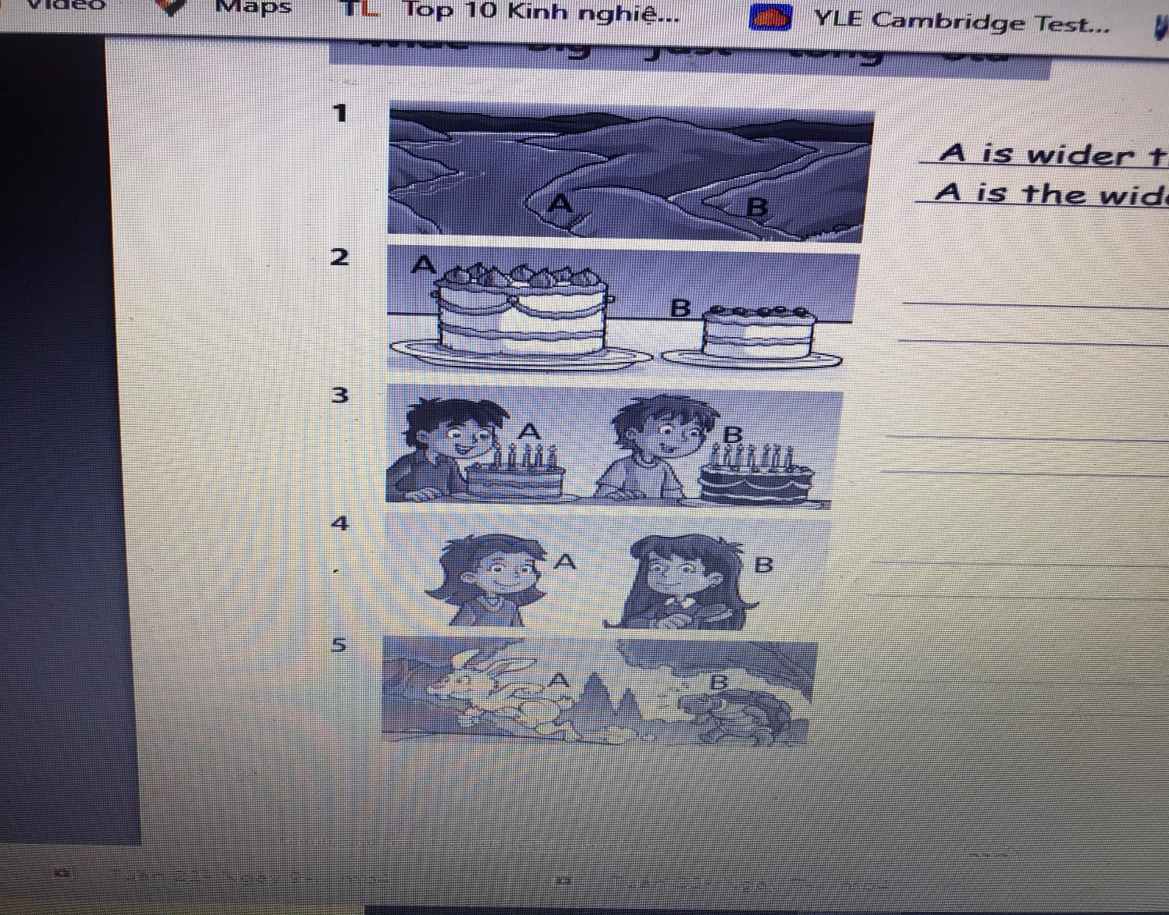

1. A is wider than B.

A is the widest.

2. _____________________

_____________________

3. _____________________

_____________________

4. _____________________

_____________________

5. _____________________

_____________________